API Automation Test Report
Practice Team Assessment

Purpose and details of document
The purpose of document is to document the objectives, environment setup, framework, test cases covered, results and conclusions of an API testing using rest assured.
Prepared By: Muhammed Ali M A
Date: 29-June-2026
GitHub Repository (Test Code) : https://github.com/ust-sdet-training/SDET
Branch: muhammed_assesement_29Jun26
Assessment: API Automation using Rest Assured

1. Objective & User Story
Objective
The objective of the Test Project is to validate a REST API functionality of the website using Rest Assured.
The automation test is used to test the scenarios that given in the assessment.
The automation test will be coded to be reusable, maintainable and easily understandable. For this POJO model must be followed. Instead of POJO we are using POJO with record in models instead of classes in models.

User story
As a QA Engineer, I want to retrieve a post and validate its details to ensure the API returns the expected data
Flow Under Test as Scenario
Question 1: Get Post
- Send a GET request to: /posts/1
- Validate:
a. Status Code = 200
b. id = 1
c. userId is present
d. title is not empty
e. body is not empty
3. Environment & Setup
Test Details
Application URL - Configured through .env
Framework - Rest Assured, Junit 5
Language - Java 22
Build Tool - Maven
Test Runner - JUnit 5
Schema Validation - JSON Schema Validator
OS - Windows 11

Environment Variables
Stored in: .env file
baseurl= (Enter the API URL of the website that testing)
Note: Here Dot Env package is used to get the evn from file

How to run the test
- Clone the repo with the project branch (git clone –branch BRANCHNAME --single-branch REPOSITORYLINK)
- Go to the API testing directory (cd apitesting)
- Run the execution commands according to the requirement

Execution Command
mvn test (To run the Whole Test)
mvn clean test (To run the Whole Test and Remove the previous tests results (the target file will get deleted)
mvn test -Dtest=ApiTest (To run the Api Test file only)
mvn test -Dtest=TESTCLASS# TESTMETHODNAME
(To run the TESTMETHODNAME inside TESTCLASS file only)

4. Framework Design
The framework we follow is POJO with record as model and we use Junit5 and rest assured.

Folder Structure
└───src
├───main
│ └───java
│ └───com
│ └───apitesting
└───test
├───java
│ └───com
│ └───apitesting
│ ├───models
│ ├───support
│ └───tests
└───resources
└───schemas
└───json
Directories and files in the framework
Tests Directory
Contains API test java files. Each Java file contains tests which covers the question.
File: ApiTest.java
Models
Contains Java Records which follows the POJO. Records will be used to pass in payload and to store the response.
Files: PostModel
Supports
Contains Java classes which supports the whole project . Supports contain utility classes for reusable methods and environment data handling, and Restassured ResponseSpecifications and RequestSpecifications.
File: Config,RequestSpec,ResponseSpec
Resources/Schemas
Contains schema files used for response validations.
File: post.schemas.json
5. Expectation
a. Rest Assured
b. Status code validation
c. JSON Path
d. Assertions
6. Results
TC_API_001 – Get post – Passed
7. Results Evidence
Test 1: Get Post
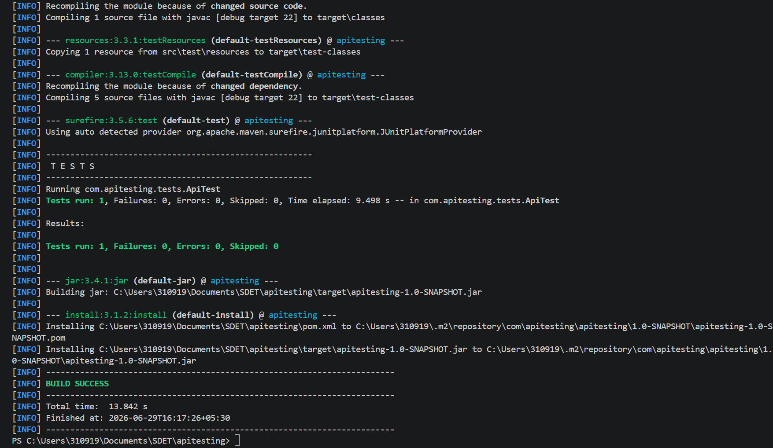

Schema:
{
"$schema": "https://json-schema.org/draft-04/schema#",
"type":"object",
"required": ["id","userId","title"],
"properties": {
"userId":{"type":"integer","minimum": 1},
"id":{"type":"integer","minimum": 1},
"body":{"type":"string"},
"title":{"type":"string","minLength":1}
}
}

9. Conclusion
a. Rest Assured -- TRUE
b. Status code validation -- TRUE
c. JSON Path -- TRUE
d. Assertions -- TRUE

- Every test successfully executed and give Expected status.
- Successfully created the API testing using REST ASSURED, Junit and POJO.

